Grade 2
Northern Corn Rootworm Beetle

Description: | Students will:  Draw an insect.  Make a script with forward and turn tiles.  Construct new tiles by adding joystick’s left/right and up/down to the forward and turn tiles.  Add a stamp tile to show the insect’s forward direction.  Learn to apply headings in motion.
Project View | 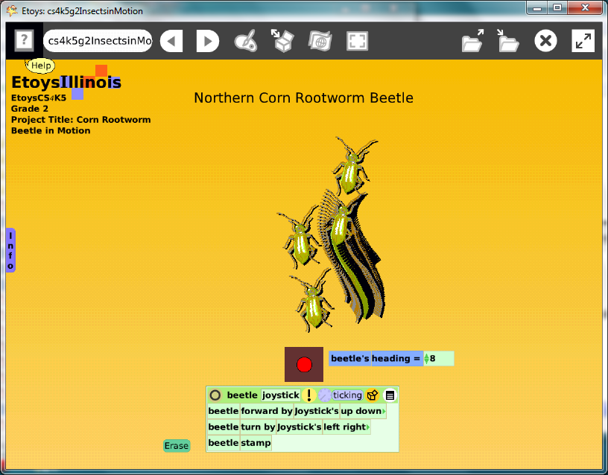
Subject: | Mathematics, Science
Etoys Quick Guides | Click the question mark in Etoys to open the set of interactive tutorials for basic tools and techniques.
Vocabulary: | Insect, head, thorax, abdomen, six legs, heading, size, enlarge, reduce, scale factor
Lesson 1:  Supplies: Digital Images  Script Tiles: Scale Factor  Paint Tools  Supplies: Grab Patch  Supplies: Text | Discuss insect’s characteristics: head thorax, abdomen, and six legs.  Provide a desktop folder of digital images for students to select butterflies, dragonflies, bees, etc.  Change the size of the digital image. The digital image details can be enlarged using the scale factor tile. Open its Viewer, click on basic and choose: geometry. The scale factor can be changed with up/down arrows and the tile can remain in the Viewer.  Give students time to experiment with scale factors. Sizes smaller than 1 use decimals. Find the limits of change and then select a good size t see details for their insect. The finished drawing’s size can be reduced using its scale factor tile. Choose a good size for the project window.  Draw or trace the overhead view of an insect. This example uses an insect common in Illinois.  It is good practice to include website information for digital images, even ones that are trace. Type it with Text or use a grab patch tool.  Keep the project. Name it: namebugjoystick
Lesson 2:  Script Tiles: Forward and Turn  Supplies: Joystick Control | Open the project from Lesson 1.  Use forward and turn tiles to make a script for the insect.  Change the script so a joystick to controls the insect’s motion.  Get a joystick from Supplies, open a Viewer, and click on basic. The menu that opens includes a special category for the joystick.  Construct a new tile by adding: joystick up down to the forward tile. Add: joystick left right to the turn tile. Start the script ticking and experiment with the joystick.  Keep the project.
Lesson 3:  Script Tiles: Stamps  Script Tiles: Pen Use  Menus: Button to Fire a Script  Menus: Simple and Detailed Watchers | Open the project from Lesson 2.  Add a stamp tile to the script so that the path of the insect can be seen.  Make an eraser to clear pen trails/stamps. Use the clear all pen trails tile. Click on the white menu in the Scriptor and choose: button to fire a script. The new button’s label can be changed by opening a halo of handles for it and choosing its white menu.  Add a detailed watcher for heading and use it to draw shapes such as square, letters, or numbers.  Keep the project: namebugjoystickfinal  Give students plenty of time to experiment with their project. Give them time to try projects by classmates. Challenges: draw circles and other geometric shapes, letters, and numbers.  Discuss what they find out about headings.
Standards: | Common Core Standards  Mathematics: 4.MD.5.a.b  Bloom’s Taxonomy/Cognitive Domain:  Knowledge: describes  Comprehension: gives examples  Application: uses  NETS  1. a
Resources: | Etoys Help Quick Guides: always available in Etoys. Open Etoys and click the question mark to open a set of interactive tutorials of basic tools and techniques.  www.etoysillinois.org projects, lesson plans, software download  www.mste.Illinois.org more math, science, and technology resources  www.corestandards.org Common Core Standards  www.squeakland.org software and Etoys projects  www.nctm.org Standards and Focal Points for each grade level
kh
January 2011

